| ***Question : Book a Ticket in online [Online Bus Reservation System]*** | | | | | | | | | |
| --- | --- | --- | --- | --- | --- | --- | --- | --- | --- |
|
|  |  |  |  |  |  |  |  |  |  |
|  |  |  |  |  |  |  |  |  |  |
| ***WHAT ?*** | | | | | ***HOW?*** | | | | |
|
| *1.What are the functionalities or modules Required ?*  ***Ans :***  ***A) Admin***  *a) Add/Delete/View/View all the Bus details*  ***Ans :*** *Bus no, Bus Route, Bus Type*  *b) Add/Delete/Update/View Fare Details*  *c) Add/Delete/Update/View Customer Details*  ***Ans :*** *Customer name, phone no, age,mail id*  *d) Add/Delete/Update/View the driver and cleaner Details*  ***Ans :*** *Driver, Cleaner Details with Mobile number*  ***B) User***  *a) Register*  *b) Login*  *c) Search a bus*  *d) Book a Bus*  *e) Cancel a Bus*  *f) Payment*  *g) Review*  *h) Travel History*  *2.Client Need a Mobile Application or Web Application?*  ***Ans :*** *Both Mobile Application and Web Application*  *3.What is the time limit you will give us?*  ***Ans :*** *4 to 6 Months*  *4.What are the languages the client needed in this project?*  ***Ans :*** *Indian languages and English( UK )*  *5.Is this application going to be open-source or closed-source?*  ***Ans :*** *Open-Source* | | | | | *01. In the admin panel, enter the bus ID and bus details with*  *add/delete/view/update by using the Text Bar.*  *02. In the admin panel, use the drop-down bar to add/delete/view/update*  *the bus ID and bus details.*  *03. In the admin panel, add, delete, or update the bus details after*  *the document verification, and your bus will be added to the app and*  *a unique identifier will be generated.*  *04.In fare, enter route in the textbox to add, delete, or update an option.*  *05. In fare select the source and destination route with*  *add,delete or update option.*  *06. After booking, provide the driver and cleaner details to the customer.*  *07. After booking, don't provide the driver and cleaner details to the customer.*  *08. Registration done by manually.*  *09. Registration done with a help of google account.*  *10. Seat selection count selection by using text box, then seat*  *will allocate automatically.*  *11. Seat selection count selection by using increment and decrement button,*  *then seats will be allocated automatically.*  *12. Seat selection will be a manual method (manual selection).*  *13. Show the Travel history in the Main Page.*  *14. Don't Show the Travel history in the Main Page.* | | | | |
|
|
|
|
|
|
|
|
|
|
|
|
|
|
|
|
|
|
|
|
|
|
|
|
| ***WHY ?*** | | | | | ***WHY NOT?*** | | | | |
|
| *01. In the admin panel, add, delete, or update the bus details after*  *the document verification, and your bus will be added to the app and*  *a unique identifier will be generated.*  *02. In fare select the source and destination route with*  *add,delete or update option.*  *03. After booking, provide the driver and cleaner details to the customer.*  *04. Registration done with a help of google account.*  *05. Seat selection will be a manual method (manual selection).*  *06. Show the Travel history in the Main Page.* | | | | | *01. In the admin panel, adding or updating some details without verification*  *may lead to a technical problem.*  *02. In fare selection, manual entry may take more time and make more mistakes.*  *03. By using a Google account, we can access it easily. In case a user forgets*  *their account password, they can access it easily by using a recovery OTP or recovery mail ID,which is more secure.*  *04. Manual seat allocation is the user's almost choice; some users want window*  *seats,and some users don't like window seats, so manual seat selection is*  *suitable for this project.*  *05. Travel history: to track the present places, I want to see*  *their previous travel details.* | | | | |
|
|
|
|
|
|
|
|
|
|
|
|
|
|
|
|
|
|
|
|
|
|
|

***ADMIN :***

***Algorithm :***

***Step 01:*** *Start*

***Step 02:*** *Create an admin panel.*

***Step 03:*** *Verify the bus documents*

***Step 04:*** *Add the bus details, Delete the bus details, Update the bus details and View the details by using an individual bus id.*

***Step 05:*** *Add the bus route, Update the bus route, Delete the bus route after adding bus details.*

***Step 06:****Admin can Add the customer details, Update the customer details, Delete the customer details .*

***Step 07:*** *Add the driver and cleaner details, Update the driver and cleaner details, Delete the driver and cleaner details.*

***Step 08:*** *stop*

***FLowchart :***

***USER :***

***Algorithm :***

***Step 01 :*** *start*

***Step 02 :*** *A new user must register his details in the registration form.*

***Step 03 :*** *After registration login to the application by using user id and password.*

***Step 04 :*** *If the user id or password is incorrect then repeat this* ***step 03*** *again.*

***Step 05 :*** *User id or password is valid goto the next step.*

***Step 06 :*** *Select the source and destination route.*

***Step 07 :*** *Show the Available seats.*

***Step 08 :*** *Book the seats.*

***Step 08 :*** *Pay the amount for booking.*

***Step 09 :*** *Get the ticket from the application.*

***Step 10 :*** *stop*

***Flowchart :***

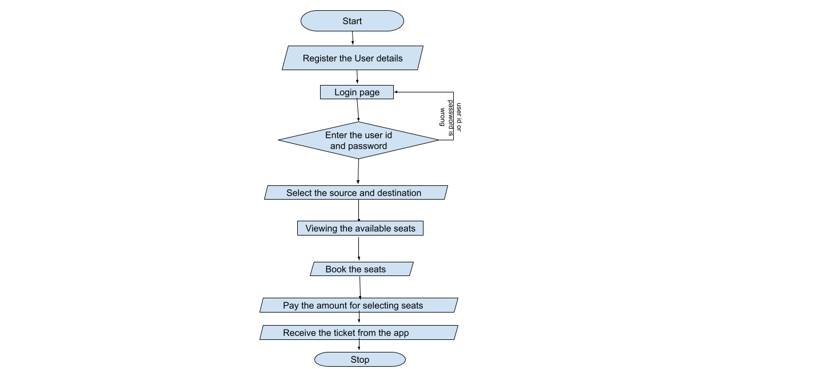

***UML***

***Admin :***

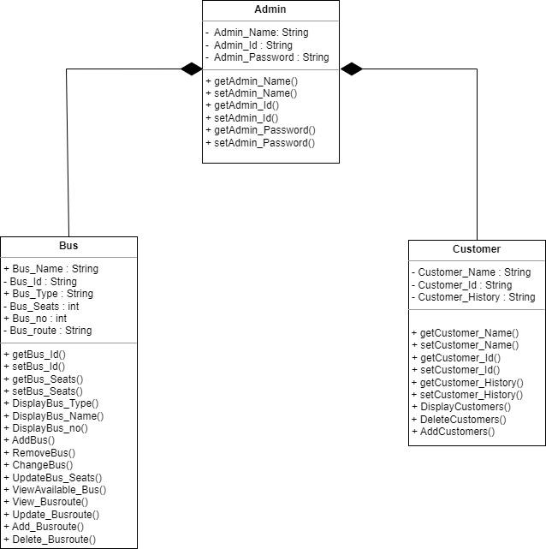

***User:***

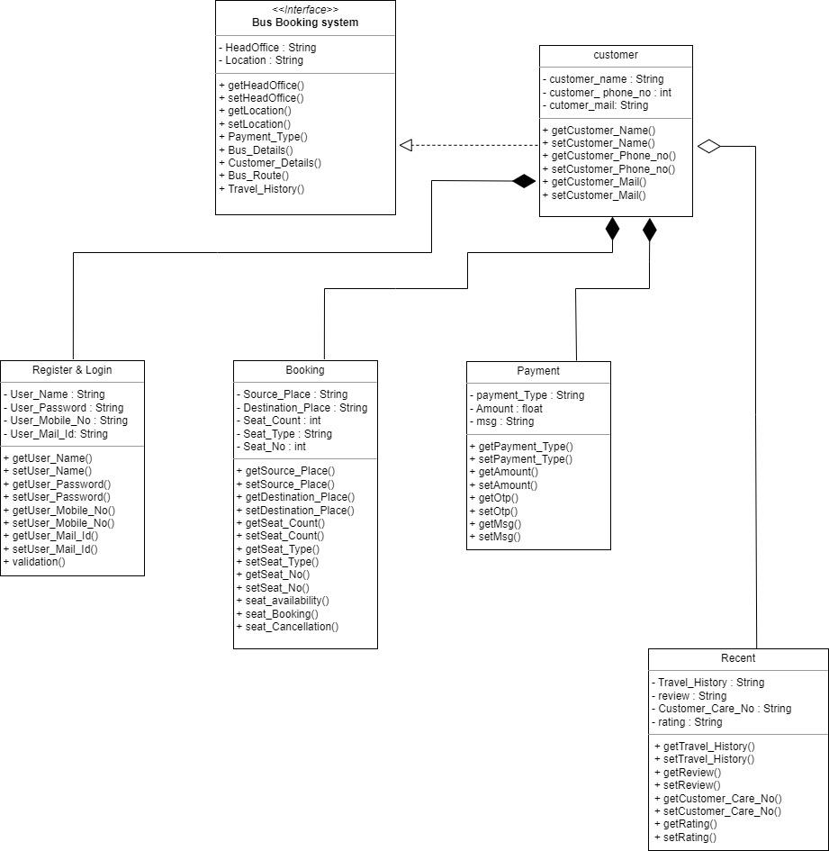

***UseCase Diagram:***

***Admin:***

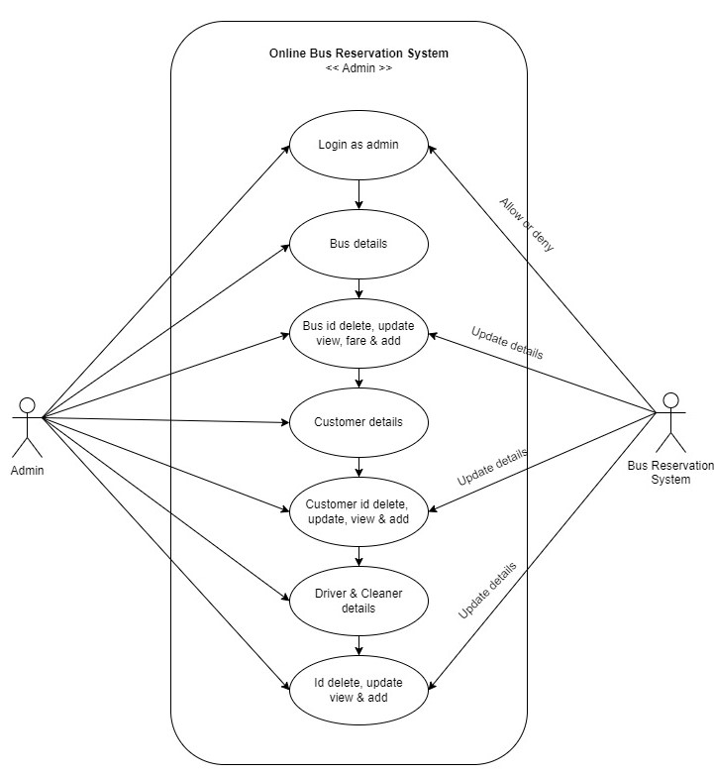

***User:***

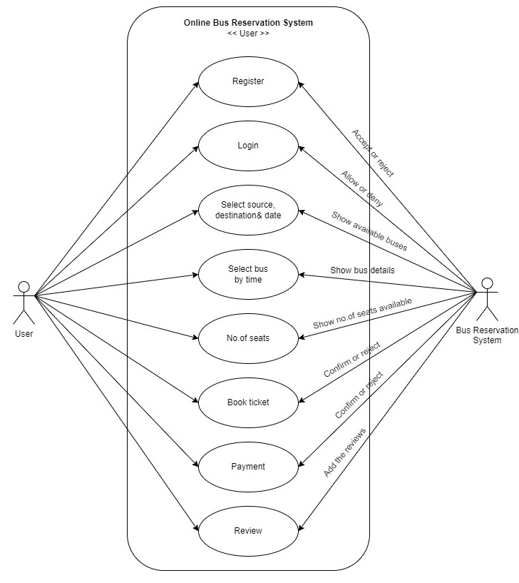

***Sequence Diagram :***

***Register & Login***

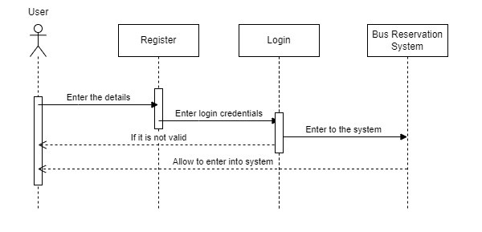

***Bus Fare :***

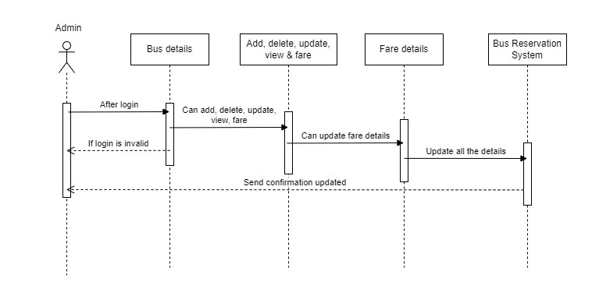

***Customer Details :***

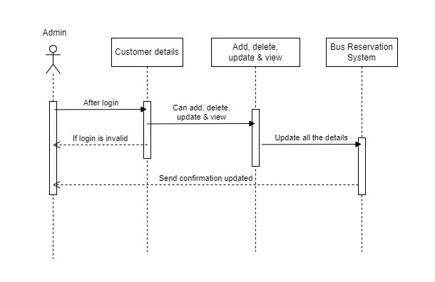

***Driver & Cleaner Details :***

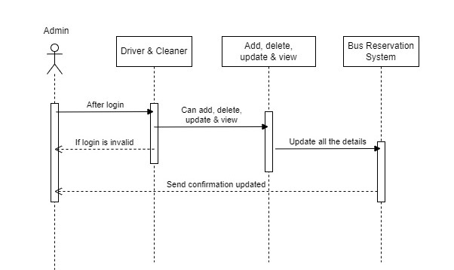

***Booking :***

